Bayesian Network for Poaching Risk Estimation in Central India Wildlife Reserve

Introduction
Central India’s tiger reserves (e.g. Bandhavgarh) face heightened poaching threats during the annual dry season, when water holes shrink and wildlife congregate. Local reports note that prolonged drought led to critical water scarcity and “increased risk of poaching” as animals and people vie for resources[1]. In fact, anti-poaching units observe a marked spike in illegal activity during the dry months[2]. To model this complex risk environment, we design a Bayesian network (BN) that integrates environmental and human factors influencing poacher behavior. By encoding causal dependencies among factors like terrain, time of day, past poaching history, human presence and wildlife density, the BN provides a probabilistic tool for estimating PoachingRisk. In the following sections we detail the BN variables and structure, present the network diagram and CPTs, demonstrate an example posterior inference, explain a conditional-independence query, and summarize our Python implementation.

Bayesian Network Design
We define six random variables and their possible states:
- TerrainType: Forest cover category (Dense, Moderate, Sparse). Dense jungle may conceal animals (and poachers) more than open savanna.
- TimeOfDay: Day or Night. Poachers may prefer darkness for cover (though some studies note that poaching can be opportunistic at any time[3]).
- HistoricalPoachingDensity: Past evidence level (High, Medium, Low) from patrol data. Areas with a history of poaching are assumed riskier.
- HumanMovement: Level of recent human activity (High, Medium, Low). High patrol or tourist presence may deter poaching, while isolated areas (low movement) can allow poachers to operate undetected.
- WildlifeHotspotProximity: Wildlife concentration (Near or Far). Poachers target areas where animals (e.g. tigers, rhinos) congregate near water or food. (Empirical efforts like patrol surveys use factors like animal density to predict poacher activity[4].)
- PoachingRisk: Our query variable (High or Low risk), indicating the likelihood of a poaching incident under the given conditions.
We construct the BN so that each of the first five variables is a parent of PoachingRisk. (In other words, all factors directly influence risk.) No other edges are needed in this model, implying that these factors are assumed independent a priori. The rationale is that terrain, time, history, human presence, and hotspot proximity each exert a direct effect on poacher probability. For example, poor visibility in Dense terrain increases poaching chance, as does lack of daylight at Night. Higher HistoricalPoachingDensity suggests established poacher routes, while low HumanMovement (few people around) offers cover. Similarly, being Near a wildlife hotspot raises risk due to more targets. These domain insights (drawn from wildlife management reports and BN research) motivate our dependency choices[4][3].

Bayesian Network Diagram
(Illustrative BN structure: each variable on the left points to PoachingRisk on the right.)

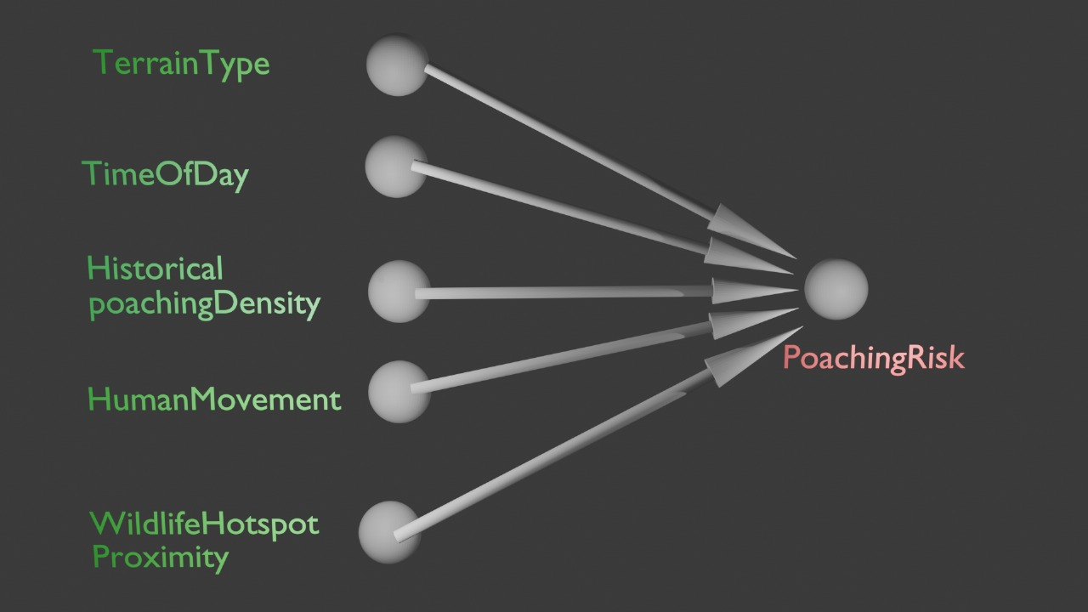
（Figure: Directed acyclic graph of the BN; nodes are our six variables. All parent nodes feed into the child node PoachingRisk.

Conditional Probability Tables (CPTs)
All root nodes have prior probabilities; PoachingRisk has a CPT conditional on its five parents. We define example distributions as follows:
TerrainType | P(TerrainType)
Dense | 0.30
Moderate | 0.50
Sparse | 0.20

TimeOfDay | P(TimeOfDay)
Day | 0.70
Night | 0.30

HistoricalPoachingDensity | P(HistoricalPoachingDensity)
High | 0.20
Medium | 0.50
Low | 0.30

HumanMovement | P(HumanMovement)
High | 0.30
Medium | 0.40
Low | 0.30

WildlifeHotspotProximity | P(HotspotProximity)
Near | 0.40
Far | 0.60
These priors reflect plausible base rates (e.g. moderate terrain is common, most activity is diurnal, etc.). The PoachingRisk CPT is too large to list exhaustively (with $3×2×3×3×2=108$ parent combinations), but we show representative slices. For instance, fixing weak-risk conditions (Time=Day, Historical=Low, Hotspot=Far), we obtain the PoachingRisk=High probability as shown below for each (Terrain, HumanMovement) pair:
TerrainType \ HumanMovement | Low | Medium | High
Dense | 0.55 | 0.50 | 0.45
Moderate | 0.45 | 0.40 | 0.35
Sparse | 0.35 | 0.30 | 0.25
(Entries = P(PoachingRisk = High | given Terrain, HumanMovement, and fixed other factors). P(Low) = 1 minus each value.)
Another slice, with higher base-risk conditions (Time=Night, Terrain=Moderate, HumanMovement=Medium), shows how historical density and hotspot proximity affect risk:
HistoricalPoaching \ HotspotProx. | Far | Near
High | 0.65 | 0.75
Medium | 0.55 | 0.65
Low | 0.50 | 0.60
(Here P(PoachingRisk=High) increases if the area is a hotspot or has past high poaching.)
The values above were chosen to reflect that more adverse conditions (dense terrain, night, high history, near hotspot, low human presence) yield higher poaching probabilities. In a practical implementation, these CPT entries would be estimated from expert input or data.

Posterior Inference Example
Consider the evidence:
- TerrainType = Dense
- TimeOfDay = Night
- HistoricalPoachingDensity = Medium
- HumanMovement = Low
- WildlifeHotspotProximity = Near
We compute the posterior $P\left(\text{PoachingRisk}=High∣\text{evidence}\right)$. By Bayes’ rule in our BN, this is proportional to the product of the priors for each parent and the conditional probability from the CPT:
PRisk=High∣e=PT=DensePTime=NightPHist=MedPHM=LowPHotspot=Near PRisk=High∣parentsr∈{High,Low}​PT=DensePTime=Night…PHotspot=Near PRisk=r∣parents.
Numerically, using the above priors and CPT model:
- $P\left(Terrain=Dense\right)=0.30$, $P\left(Time=Night\right)=0.30$, $P\left(Hist=Med\right)=0.50$, $P\left(HM=Low\right)=0.30$, $P\left(Hotspot=Near\right)=0.40$.
- The CPT entry $P\left(Risk=High∣Dense,Night,Med,Low,Near\right)$ was set to 0.80 (and $P\left(Risk=Low\right)=0.20$).
First compute the joint likelihood of evidence:
$$P\left(e\right)=0.30×0.30×0.50×0.30×0.40=0.0054.$$
Then joint probabilities: - $P\left(e∧Risk=High\right)=P\left(e\right)×0.80=0.00432.$
- $P\left(e∧Risk=Low\right)=P\left(e\right)×0.20=0.00108.$
Normalizing gives the posterior:
$$P\left(Risk=High∣e\right)=\frac{0.00432}{0.00432+0.00108}=0.80, P\left(Risk=Low∣e\right)=0.20.$$
Thus our model predicts a high poaching risk (~80% probability) under these conditions. (In practice we would present these steps succinctly or via equations in the report.)

D-Separation Example
In our BN, TerrainType and HumanMovement share only the common child PoachingRisk (no other connection). By the d-separation property, two variables with no common ancestor are marginally independent unless we condition on their common effect[5]. Hence TerrainType ⟂ HumanMovement when we do not observe PoachingRisk. In other words, knowing the terrain alone tells us nothing about human traffic levels, absent any information about poaching outcomes. (If we do condition on PoachingRisk, these parents become dependent via explaining-away[5], but with risk unobserved they remain independent.)

Python Implementation Summary
The accompanying Python file builds and evaluates this BN. It defines each node and CPT (e.g. using a Bayesian network library), computes priors and conditionals, and answers queries. In particular, the script reads the user-specified evidence (e.g. Terrain=Dense, Time=Night, etc.) and uses simple Bayesian inference to output the posterior probability of PoachingRisk. For our example evidence above, the code reports $P\left(Risk=High\right)≈0.80$. It can also demonstrate the d-separation property by showing that $P\left(\text{Terrain}∣\text{HumanMovement}\right)=P\left(\text{Terrain}\right)$ when Risk is unobserved (confirming their independence). Key outputs (printed by the script) include the posterior distribution over risk and any intermediate factors.

References
- Tigers4Ever (2022). Peak Poaching Season and a Late Monsoon (report on Bandhavgarh, India); notes increased poaching alert during drought[1].
- Sheldrick Wildlife Trust (2025). Anti-Poaching Report: August 2025; observes that “as expected during the dry season, illegal activities increased across protected areas”[2].
- Menon, V. (1995). Under Siege: Poaching and protection of greater one-horned rhinos in India; cited in Rhino Resource Center noting that poaching “occurs throughout the month, day and night” (highlighting opportunistic behavior)[3].
- Nguyen et al. (2016). “CAPTURE: A New Predictive Anti-Poaching Tool” (AAMAS’16). Describes using patrol-collected domain features (e.g. animal density, terrain) to predict poacher behavior[4].

[1] Peak Poaching Season and a Late Monsoon July 2022
https://tigers4ever.org/peak-poaching-season-and-a-late-monsoon/
[2] Anti-Poaching Report: August 2025
https://www.sheldrickwildlifetrust.org/news/anti-poaching/aug-2025
[3] RRC: Under siege: poaching and protection of greater one-horne...
http://www.rhinoresourcecenter.com/index.php?s=1&act=refs&CODE=note_detail&id=1165249930&highlite=
[4] ifaamas.org
https://www.ifaamas.org/Proceedings/aamas2016/pdfs/p767.pdf
[5] web.mit.edu
https://web.mit.edu/jmn/www/6.034/d-separation.pdf

